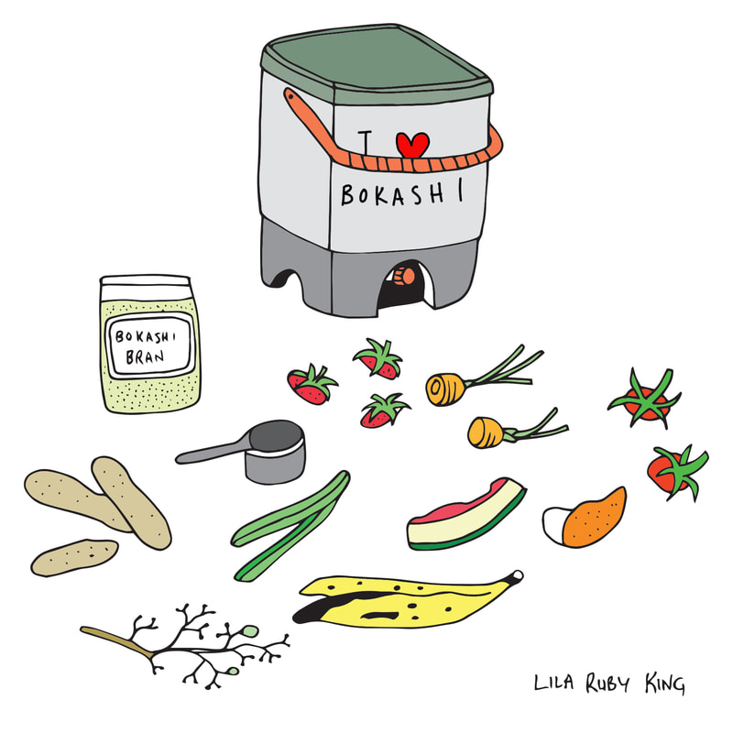
Do-It-Yourself “Bokashi Bran Workshop”
Date: November 13, 2026
Time: 9:00 AM– 12:00 PM
Location:
Santa Fe County Extension Campus
3229 Rodeo Rd., Santa Fe, NM 87507
Meeting in the Exhibit Hall
Organizer:
Santa Fe Compost Action Team (SCAT), a project of the Santa Fe Extension Master Gardeners.

This “Bokashi Bran Making Workshop” is for anyone who is already practicing Bokashi Composting. Commercially purchased Bokashi bran normally costs about $8.85 per pound, plus shipping. Our cost will be $2.00 per pound. Make as little as 7 pounds ($14) or more in increments of 7 pounds.
Must register by November 7, 2026.
Public Workshop - Do-it-yourself Bokashi Bran. Sign up here

